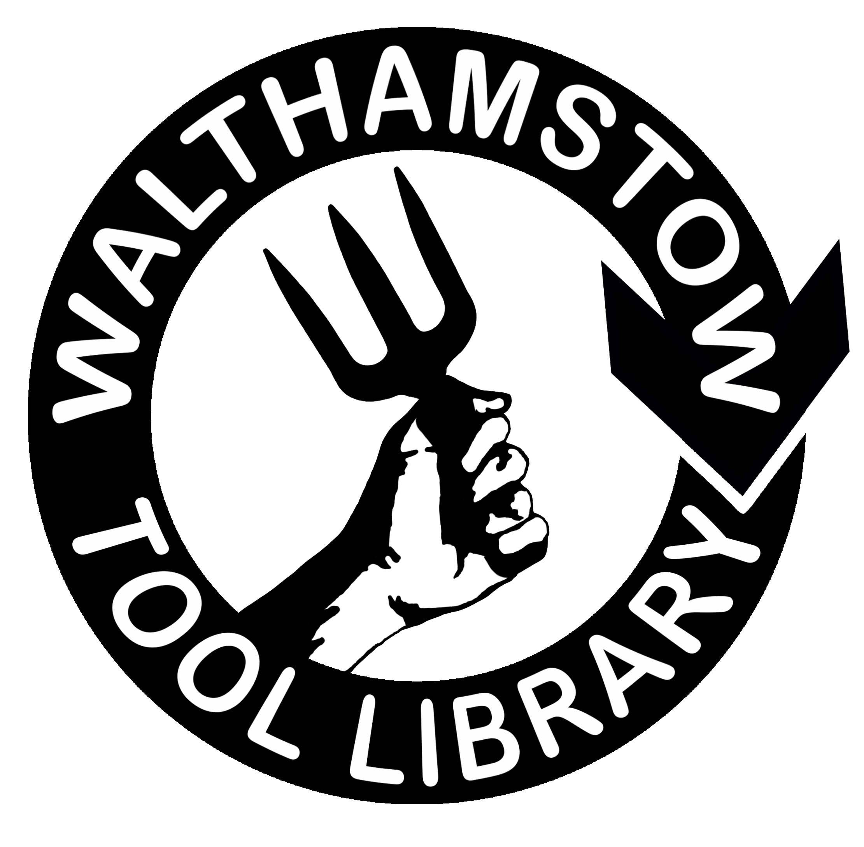
Would you like to run an activity
for the local community around the tool library?

Name:

Address:

Your project idea: You can either write on this form and hand it into the Tool Library, or send it electronically to tools@frpuk.org.
What is the activity that you would like to do? Please tell us all about it, and where and when you would like to run it.

Who do you think would come to the activity? And how many people could participate?

Please tell us a bit about yourself. Why would you like to do this? Have you done anything like this before?

What funding and support would you need from us? Please give us a rough budget for your planned activity.

How can we contact you?

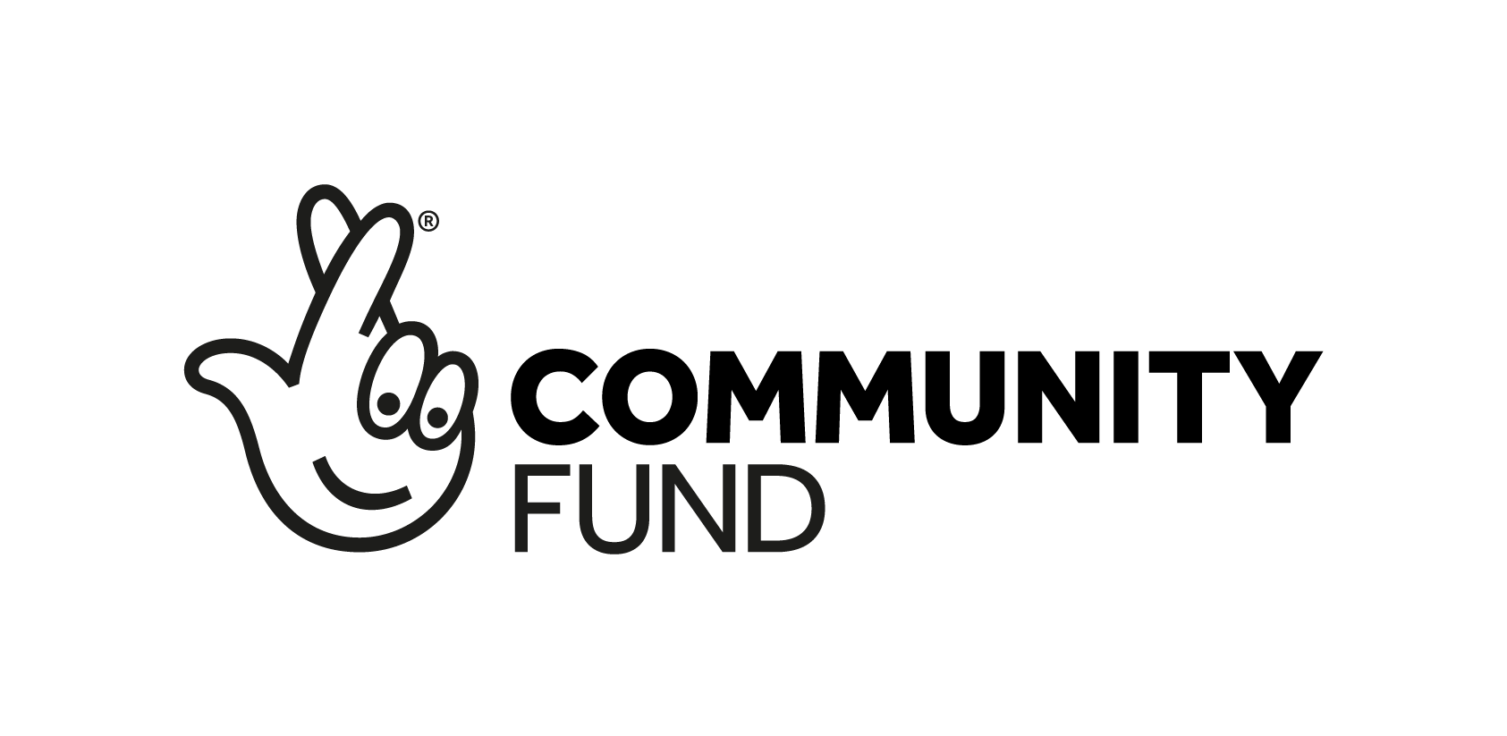
Date: Signature:

Please feel free to expand this form electronically, or continue overleaf.

